**Preemtive Schedulling Algorithms**

**1)Shortest Remaining Time First (SRTF)**

#include<stdio.h>

#include<stdlib.h>

/// -> Shortst remaining time first Preemtive Algorithm

/// -> Adnan Ismail Shah Muzavor

#define MAX 1000

typedef struct array

{

int b_time; ///burst_time

int a_time; ///arrival time

int rem_btime; ///manipulative btime

} Prc;

float avg(int *arr,int n)

{

int i=0;

float sum=0.0;

for(i=0; i<n; i++) sum+=(float)(arr[i]);

return sum/(float)n;

}

void display(int *tt,int *wt,int n)

{

int i;

printf("\n");

printf("\nProcess \t Waiting Time \t Turnaround Time");

for(i=0; i<n; i++)

{printf("\n %d \t\t %d \t\t %d",i+1,wt[i],tt[i]);}

printf("\n Avg \t\t %.2f \t\t %.2f",avg(wt,n),avg(tt,n));

}

///Display the input/sorted/processed input

void raw_display(int order[],Prc p1[],int n)

{

int i;

for(i=0; i<n; i++)

{printf(" p%d \t\t%d\t\t\t%d\n",order[i]+1,p1[i].a_time,p1[i].b_time); }

}

void SRTF(Prc *p,int first_p,int n)

{

int count=0; ///No processses completed as yet

int time=0,i=0,gantt_len=0; ///We will increment timer b y one each time

int select_process=-1;

int *wt=(int*)malloc(sizeof(int)*n);

int *tt=(int*)malloc(sizeof(int)*n);

int *gantt_processno=(int*)malloc(sizeof(int)*50);

int *gantt_time=(int*)malloc(sizeof(int)*50);

for(i=0; i<n; i++)

{

wt[i]=0;

tt[i]=0;

}

///Iterate until all processes are done

for(time=0; count!=n; time++)

{

int small=MAX;

select_process=-1; ///No process is selected

///1) -> Process selection

///Find process which had arrived udring this time

///If many consider one with minimum rem_btime

for(i=0; i<n; i++)

{

///If process had arrived and it's not completed process

if(p[i].a_time<=time && p[i].rem_btime!=0)

{

///If no0 processs was selected select this

if(select_process==-1)select_process=i;

///If this process has lesser remaining burst time

else if(p[i].rem_btime<p[select_process].rem_btime) select_process=i;

}

}

///2) Since we are executing at rate of 1 second

/// decrese the burst time for this process by only if selected

///If process was selected

if(select_process!=-1)

{

///add detials in gantt chart

gantt_processno[gantt_len]=select_process;

gantt_time[gantt_len]=time;

gantt_len++;

///decrement it's b time by one

p[select_process].rem_btime--;

///If process completed it's execution, calculate waiting and turn around time

if(p[select_process].rem_btime==0)

{

wt[select_process]=time-p[select_process].b_time-p[select_process].a_time+1; ///+1 because execution will finish at time+1

tt[select_process]=wt[select_process]+p[select_process].b_time;

///Increment counter by one as one process completed the execution

count++;

}

}

}

display_gantt(gantt_processno,gantt_time,time,gantt_len);

display(tt,wt,n);

}

void display_gantt(int *gantt_processno,int * gantt_time,int time,int gantt_len)

{

int i;

printf("\n");

for(i=0; i<gantt_len; i++)

{printf("-----");}

printf("\n");

for(i=0; i<gantt_len; i++)

{ printf("| p%d ",gantt_processno[i]+1); }

printf("|");

printf("\n");

for(i=0; i<gantt_len; i++)

{printf("-----");}

printf("\n");

for(i=0; i<gantt_len; i++)

{

if(gantt_time[i]>=10) printf("%d ",gantt_time[i]);

else printf(" %d ",gantt_time[i]);

}

printf("%d",time);

}

///To take inputs

void input(Prc *p,int* p_order,int n)

{

int i;

int min_a=1000,min_p=-1,min_b=1000; ///choose process which arrive first.If 2?choose one with min b_time

for(i=0; i<n; i++) p_order[i]=i;

printf("\nEnter the BURST time and ARRIVAL time for: \n");

for(i=0; i<n; i++)

{

printf("Process %d: ",i+1);

scanf("%d",&p[i].b_time);

scanf("%d",&p[i].a_time);

p[i].rem_btime=p[i].b_time;

}

printf("Process\t\tArrival time\t\tBurst time\n");

raw_display(p_order,p,n);

}

int main()

{

int n,i,first_p;

int min_a=1000,min_p=-1,min_b=1000; ///choose process which arrive first.If 2?choose one with min b_time

printf("Enter the number of processes: ");

scanf("%d",&n);

Prc *p1=(Prc*)malloc(sizeof(Prc)*n);

int *pr_order=(int*)malloc(sizeof(int)*n); ///For storing process order

input(p1,pr_order,n);

printf("\nAfter Shortest Remaining Time First Schedulling: ");

printf("\n");

SRTF(p1,pr_order,n);

return 0;

}

**Output:**

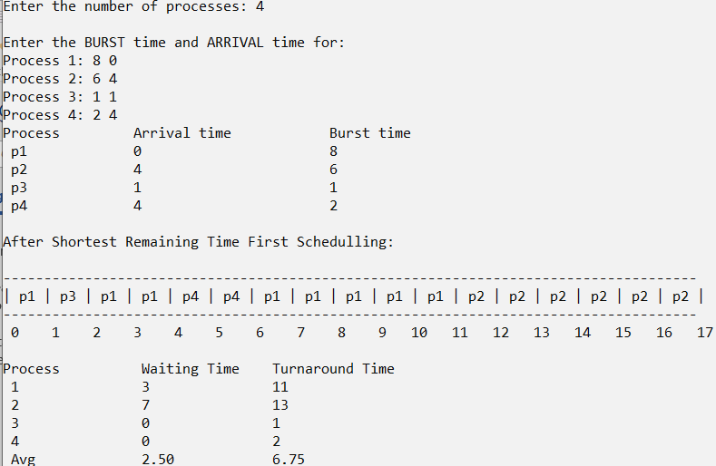

**2) Round Robin Schedulling (RR)**

#include<stdio.h>

#include<stdlib.h>

/// -> Round Robin Schedulling

/// -> Adnan Ismail Shah Muzavor

float avg(int *arr,int n)

{

int i=0;

float sum=0.0;

for(i=0; i<n; i++) sum+=(float)(arr[i]);

return sum/(float)n;

}

void display(int *tt,int *wt,int n)

{

int i;

printf("\nProcess \t Waiting Time \t Turnaround Time");

for(i=0; i<n; i++)

{

printf("\n %d \t\t %d \t\t %d",i+1,wt[i],tt[i]);

}

printf("\n Avg \t\t %.2f \t\t %.2f",avg(wt,n),avg(tt,n));

}

void RR(int *pb,int n,int ts,int *rem_btime)

{

int *wt=(int*)malloc(sizeof(int)*n);

int *tt=(int*)malloc(sizeof(int)*n);

int *gantt_processno=(int*)malloc(sizeof(int)*50);

int *gantt_time=(int*)malloc(sizeof(int)*50);

int time=0,i=0,gantt_len=0;

for(i=0; i<n; i++)

{

wt[i]=0;

tt[i]=0;

}

while(1)

{

int c=1; ///Assume all processes are done/completed

///Every tiem loop will start from process 01 i.e first process

for(i=0; i<n; i++)

{

if(rem_btime[i]>0) c=0; ///Process is left

///Processs has sufficent burst time left

if(rem_btime[i]>=ts)

{

rem_btime[i]-=ts; ///Process executed for given time slice

gantt_processno[gantt_len]=i;

gantt_time[gantt_len]=time;

gantt_len++;

time+=ts;

if(rem_btime[i]==0)

{

///Process completed, find TT and WT

wt[i]=time-pb[i]; ///Method in reference text book

tt[i]=wt[i]+pb[i];///TT=WT+BT

continue;

}

}

///Process remaining time is lesser then time slice

else if(rem_btime[i]!=0 && rem_btime[i]<ts)

{

gantt_processno[gantt_len]=i;

gantt_time[gantt_len]=time;

gantt_len++;

time+=rem_btime[i]; ///Burst time lesser then time slice hence we add the btime

rem_btime[i]=0;

wt[i]=time-pb[i]; ///Method in reference text book

tt[i]=wt[i]+pb[i];///TT=WT+BT

}

}

if(c==1)

{///Completed is true, hence break the outer loop

break; }

}

display_gantt(gantt_processno,gantt_time,time,gantt_len);

display(tt,wt,n);

}

void display_gantt(int *gantt_processno,int * gantt_time,int time,int gantt_len)

{

int i;

printf("\n");

for(i=0; i<gantt_len; i++){printf("-----");}

printf("\n");

for(i=0; i<gantt_len; i++){ printf("| p%d ",gantt_processno[i]+1);}

printf("|");

printf("\n");

for(i=0; i<gantt_len; i++){printf("-----");}

printf("\n");

for(i=0; i<gantt_len; i++)

{

if(gantt_time[i]>=10) printf("%d ",gantt_time[i]);

else printf(" %d ",gantt_time[i]);

}

printf("%d",time);

printf("\n");

}

int main()

{

int n,i,first_p,ts;

int min_a=1000,min_p=-1,min_b=1000; ///choose process which arrive first.If 2?choose one with min b_time

printf("Enter the number of processes: ");

scanf("%d",&n);

int *p_btime=(int*)malloc(sizeof(int)*n); ///number of processes

int *btime_cpy=(int*)malloc(sizeof(int)*n); ///Manipulative burst time

int *pr_order=(int*)malloc(sizeof(int)*n); ///For storing process order

printf("\nEnter the burst time for each process: \n");

for(i=0; i<n; i++)

{

printf("process: %d : ",i+1);

scanf("%d",&p_btime[i]);

btime_cpy[i]=p_btime[i];

}

printf("\nEnter the time slice: ");

scanf("%d",&ts);

printf("\n");

printf("Process \t Burst Time");

for(i=0; i<n; i++)

{printf("\np%d \t\t %d",i+1,p_btime[i]); }

printf("\n");

printf("\nAfter Round Robin Schedulling: ");

printf("\n");

RR(p_btime,n,ts,btime_cpy);

return 0;

}

**Output:**

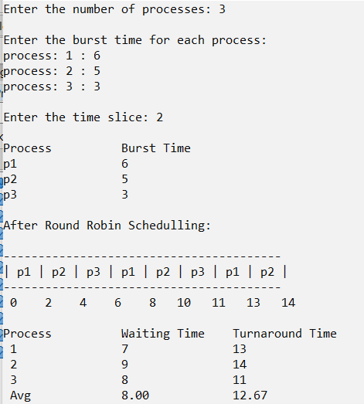

***3) Preemtive Priority Schedulling (PP)***

#include<stdio.h>

#include<stdlib.h>

/// -> Preemtive Priority Schedulling

/// -> Adnan Ismail Shah Muzavor

#define MAX 1000

typedef struct array

{

int b_time; ///burst_time

int a_time; ///arrival time

int rem_btime; ///manipulative btime

int priority; ///priority of process

} Prc;

float avg(int *arr,int n)

{

int i=0;

float sum=0.0;

for(i=0; i<n; i++) sum+=(float)(arr[i]);

return sum/(float)n;

}

void display(int *tt,int *wt,int n)

{

int i;

printf("\n");

printf("\nProcess \t Waiting Time \t Turnaround Time");

for(i=0; i<n; i++)

{printf("\n %d \t\t %d \t\t %d",i+1,wt[i],tt[i]); }

printf("\n Avg \t\t %.2f \t\t %.2f",avg(wt,n),avg(tt,n));

}

///Display the input/sorted/processed input

void raw_display(int order[],Prc p1[],int n)

{

int i;

for(i=0; i<n; i++)

{printf(" p%d \t\t%d\t\t\t%d\t\t\t%d\n",order[i]+1,p1[i].a_time,p1[i].b_time,p1[i].priority); }

}

void PPS(Prc *p,int first_p,int n)

{

int count=0; ///No processses completed as yet

int time=0,i=0,gantt_len=0; ///We will increment timer b y one each time

int select_process=-1;

int *wt=(int*)malloc(sizeof(int)*n);

int *tt=(int*)malloc(sizeof(int)*n);

int *gantt_processno=(int*)malloc(sizeof(int)*50);

int *gantt_time=(int*)malloc(sizeof(int)*50);

for(i=0; i<n; i++)

{wt[i]=0;

tt[i]=0; }

///Iterate until all processes are done

for(time=0; count!=n; time++)

{

int small=MAX;

select_process=-1; ///No process is selected

///1) -> Process selection

///Find process which had arrived udring this time

///If many consider one with minimum rem_btime

for(i=0; i<n; i++)

{

///If process had arrived and it's not completed process

if(p[i].a_time<=time && p[i].rem_btime!=0)

{

///If no0 processs was selected select this

if(select_process==-1)select_process=i;

///If this process has higher priority, execute it

else if(p[i].priority<p[select_process].priority) select_process=i;

///If this process has same priority but lesser remaining burst time

else if(p[i].priority==p[select_process].priority && p[i].rem_btime<p[select_process].rem_btime) select_process=i;

}

}

///2) Since we are executing at rate of 1 second

/// decrese the burst time for this process by only if selected

///If process was selected

if(select_process!=-1)

{

///add detials in gantt chart

gantt_processno[gantt_len]=select_process;

gantt_time[gantt_len]=time;

gantt_len++;

///decrement it's b time by one

p[select_process].rem_btime--;

///If process completed it's execution, calculate waiting and turn around time

if(p[select_process].rem_btime==0)

{

wt[select_process]=time-p[select_process].b_time-p[select_process].a_time+1; ///+1 because execution will finish at time+1

tt[select_process]=wt[select_process]+p[select_process].b_time;

///Increment counter by one as one process completed the execution

count++;

}

}

}

display_gantt(gantt_processno,gantt_time,time,gantt_len);

display(tt,wt,n);

}

void display_gantt(int *gantt_processno,int * gantt_time,int time,int gantt_len)

{

int i;

printf("\n");

for(i=0; i<gantt_len; i++)

{printf("-----");}

printf("\n");

for(i=0; i<gantt_len; i++)

{printf("| p%d ",gantt_processno[i]+1); }

printf("|");

printf("\n");

for(i=0; i<gantt_len; i++)

{printf("-----"); }

printf("\n");

for(i=0; i<gantt_len; i++)

{

if(gantt_time[i]>=10) printf("%d ",gantt_time[i]);

else printf(" %d ",gantt_time[i]);

}

printf("%d",time);

}

///To take inputs

void input(Prc *p,int* p_order,int n)

{

int i;

int min_a=1000,min_p=-1,min_b=1000; ///choose process which arrive first.If 2?choose one with min b_time

for(i=0; i<n; i++) p_order[i]=i;

printf("\nEnter the BURST time, ARRIVAL time and PRIORITY for: \n");

for(i=0; i<n; i++)

{

printf("Process %d: ",i+1);

scanf("%d",&p[i].b_time);

scanf("%d",&p[i].a_time);

scanf("%d",&p[i].priority);

p[i].rem_btime=p[i].b_time;

}

printf("Process\t\tArrival time\t\tBurst time\t\tPriority\n");

raw_display(p_order,p,n);

}

int main()

{

int n,i,first_p;

int min_a=1000,min_p=-1,min_b=1000; ///choose process which arrive first.If 2?choose one with min b_time

printf("Enter the number of processes: ");

scanf("%d",&n);

Prc *p1=(Prc*)malloc(sizeof(Prc)*n);

int *pr_order=(int*)malloc(sizeof(int)*n); ///For storing process order

input(p1,pr_order,n);

printf("\nAfter Preemtive Priority Schedulling First Schedulling: ");

printf("\n");

PPS(p1,pr_order,n);

return 0;

}

***Output:***

